**Room Occupancy Detection**

The aim of this project is to predict whether a room is occupied or not based on the data collected from the sensors. The data set is collected from the UCI Machine Learning Repository. The data set contains 7 attributes. The attributes are date, temperature, humidity, light, CO2, humidity ratio and occupancy. The data set is divided into 3 data sets for training and testing. The data set provides experimental data used for binary classification (room occupancy of an office room) from Temperature, Humidity, Light and CO2. Ground-truth occupancy was obtained from time stamped pictures that were taken every minute.

# Data Dictionary

**Column Atrribute % Null**

**Definition Data Type Example**

**Position Name Ratios**

2/4/2015

Date & time in year- 17:57,

month-day 2/4/2015

1 Date Qualitative 0

hour:minute:second 17:55,

format 2/4/2015

18:06

|  |  |  |  |  |  |
| --- | --- | --- | --- | --- | --- |
| 2 | Temperature | Temperature in degree  Celcius | Quantitative | 23.150,  23.075, 22.890 | 0 |
| 3 | Humidity | Relative humidity in percentage | Quantitative | 27.272000,  27.200000,  27.390000 | 0 |
| 4 | Light | Illuminance  measurement in unit Lux | Quantitative | 426.0, 419.0,  0.0 | 0 |
| 5 | CO2 | CO2 in parts per million  (ppm) | Quantitative | 489.666667,  495.500000,  534.500000 | 0 |
| 6 | HumidityRatio | Humadity ratio: Derived quantity from  temperature and relative humidity, in kgwatervapor/kg-air | Quantitative | 0.004986,  0.005088,  0.005203 | 0 |
| 7 | Occupancy | Occupied or not: 1 for occupied and 0 for not occupied | Quantitative | 1, 0 | 0 |

|  |
| --- |
| *#importing the libraries* **import** numpy **as** np **import** pandas **as** pd **import** matplotlib.pyplot **as** plt **import** seaborn **as** sns |

In [ ]:

Loading two datasets and combining them into one dataset

|  |  |  |  |
| --- | --- | --- | --- |
| *#loading the datasets*  df1 **=** pd**.**read_csv('datatest.csv') df2 **=** pd**.**read_csv('datatraining.csv') |  |  |  |
|  |  |  |  |
| *#combining the datasets* df **=** pd**.**concat([df1,df2]) df**.**head() |  |  |  |
| **date Temperature Humidity** | **Light** | **CO2** | **HumidityRatio Occupancy** |

In [ ]:

In [ ]:

Out[ ]:

2/2/2015

**0** 23.7000 26.272 585.200000 749.200000 0.004764 1

14:19

|  |  |  |  |  |  |  |
| --- | --- | --- | --- | --- | --- | --- |
| **1** | 2/2/2015 14:19 | 23.7180 | 26.290 | 578.400000 | 760.400000 | 0.004773 |
| **2** | 2/2/2015 14:21 | 23.7300 | 26.230 | 572.666667 | 769.666667 | 0.004765 |
| **3** | 2/2/2015 14:22 | 23.7225 | 26.125 | 493.750000 | 774.750000 | 0.004744 |
| **4** | 2/2/2015 14:23 | 23.7540 | 26.200 | 488.600000 | 779.000000 | 0.004767 |

1

1

1

1

# Data Preprocessing

In [ ]: *#number of rows and columns* df**.**shape

|  |  |
| --- | --- |
| Out[ ]: | (10808, 7) |

In [ ]: *#checking for null values* df**.**isnull()**.**sum()

|  |  |
| --- | --- |
| Out[ ]: | date 0 Temperature 0  Humidity 0  Light 0  CO2 0  HumidityRatio 0 Occupancy 0 dtype: int64 |

In [ ]: *#checking for duplicate values* df**.**duplicated()**.**sum()

|  |  |
| --- | --- |
| Out[ ]: | 27 |

In [ ]: *#removing the duplicate values* df**.**drop_duplicates(inplace**=True**)

In [ ]: *#checking data types* df**.**dtypes

|  |  |
| --- | --- |
| Out[ ]: | date object Temperature float64  Humidity float64  Light float64  CO2 float64  HumidityRatio float64 Occupancy int64 dtype: object |

In [ ]: *#converting the date and time to datetime format* df['date'] **=** pd**.**to_datetime(df['date'])

In [ ]: df**.**dtypes

Out[ ]: date datetime64[ns] Temperature float64

Humidity float64

Light float64

CO2 float64

HumidityRatio float64 Occupancy int64 dtype: object

In [ ]: *#checking the descriptive statistics* df**.**describe()

Out[ ]: **date Temperature Humidity Light CO2 Hum**

**count** 10781 10781.000000 10781.000000 10781.000000 10781.000000 10

|  |  |  |  |  |  |
| --- | --- | --- | --- | --- | --- |
| **mean** | 2015-02-06  13:41:14.581207808 | 20.821800 | 25.638618 | 138.036704 | 634.460328 |
| **min** | 2015-02-02 14:19:00 | 19.000000 | 16.745000 | 0.000000 | 412.750000 |
| **25%** | 2015-02-04 18:23:00 | 20.000000 | 21.390000 | 0.000000 | 441.000000 |
| **50%** | 2015-02-06 15:24:00 | 20.700000 | 25.680000 | 0.000000 | 464.000000 |
| **75%** | 2015-02-08 12:29:00 | 21.500000 | 28.323333 | 415.000000 | 763.000000 |
| **max** | 2015-02-10 09:33:00 | 24.408333 | 39.117500 | 1697.250000 | 2028.500000 |
| **std** | NaN | 1.078589 | 4.954838 | 212.330275 | 313.074686 |

|  |
| --- |
| *#value counts for the target variable i.e. occupancy* df['Occupancy']**.**value_counts() |

In [ ]:

Out[ ]: Occupancy 0 8080

1 2701

Name: count, dtype: int64

# Exploratory Data Analysis

In the exploratory data analysis, we will be looking at the distribution of the data, along with the time series of the data. We will also be looking at the correlation between the variables.

## Visualizing the temperture fluctuations over time

|  |
| --- |
| *#lineplot for themperature changes for time* plt**.**figure(figsize**=**(20,10)) sns**.**lineplot(x**=**'date',y**=**'Temperature',data**=**df) plt**.**show() |

In [ ]:

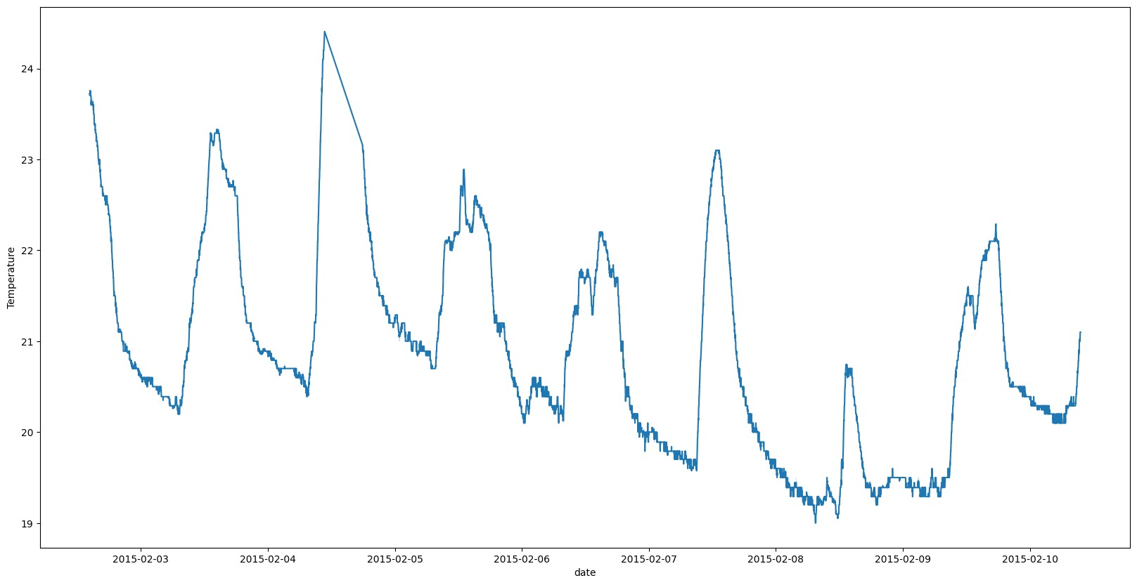

The spikes in the graph clearly indicates that the room temperature incresases suddenly which might be due to the presence of people in the room. The temperature of the room may increase due to the heat emitted by the human body.

## Visualizing the humidity fluctuations over time

|  |
| --- |
| *#lineplot for humidity changes for time* plt**.**figure(figsize**=**(20,10)) sns**.**lineplot(x**=**'date',y**=**'Humidity',data**=**df) plt**.**show() |

In [ ]:

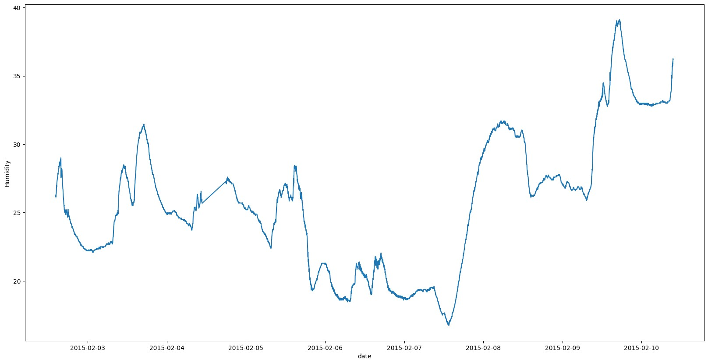

The line graph between 3rd of February to 6th of February shows some similarity with the temperature graph, which might be due to the presence of people in the room. However 7th of February onwards there has been a significant rise in the humidity levels which might be due to cleaning of the room, or change in the weather conditions. Out of which room cleaning such sweeping the floor might be the reason for the sudden rise in the humidity levels. But it couldn't explain the increase in the humidity levels near 10th of February.

## Visualizing the light fluctuations over time

|  |
| --- |
| *#lineplot for light changes for time* plt**.**figure(figsize**=**(20,10)) sns**.**lineplot(x**=**'date',y**=**'Light',data**=**df) plt**.**show() |

In [ ]:

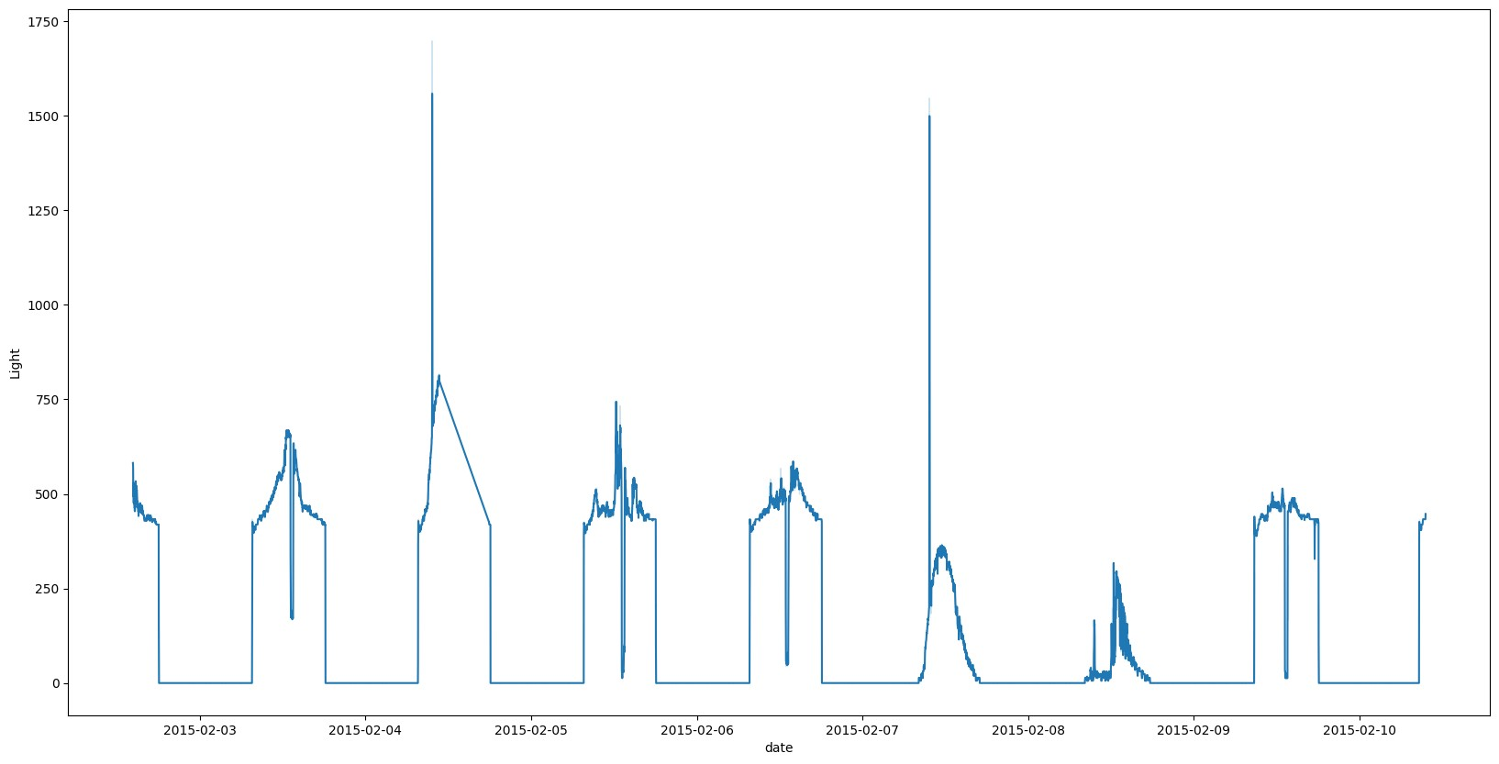

If we look closely, we can see that the number of peaks in this graph and in the temperature graph are same. This indicates that lights were turned on when there was a person in the room. This is a good indicator of the occupancy of the room.

### Visualizing the CO2 fluctuations over time

|  |
| --- |
| *#lineplot for co2 changes for time* plt**.**figure(figsize**=**(20,10)) sns**.**lineplot(x**=**'date',y**=**'CO2',data**=**df) plt**.**show() |

In [ ]:

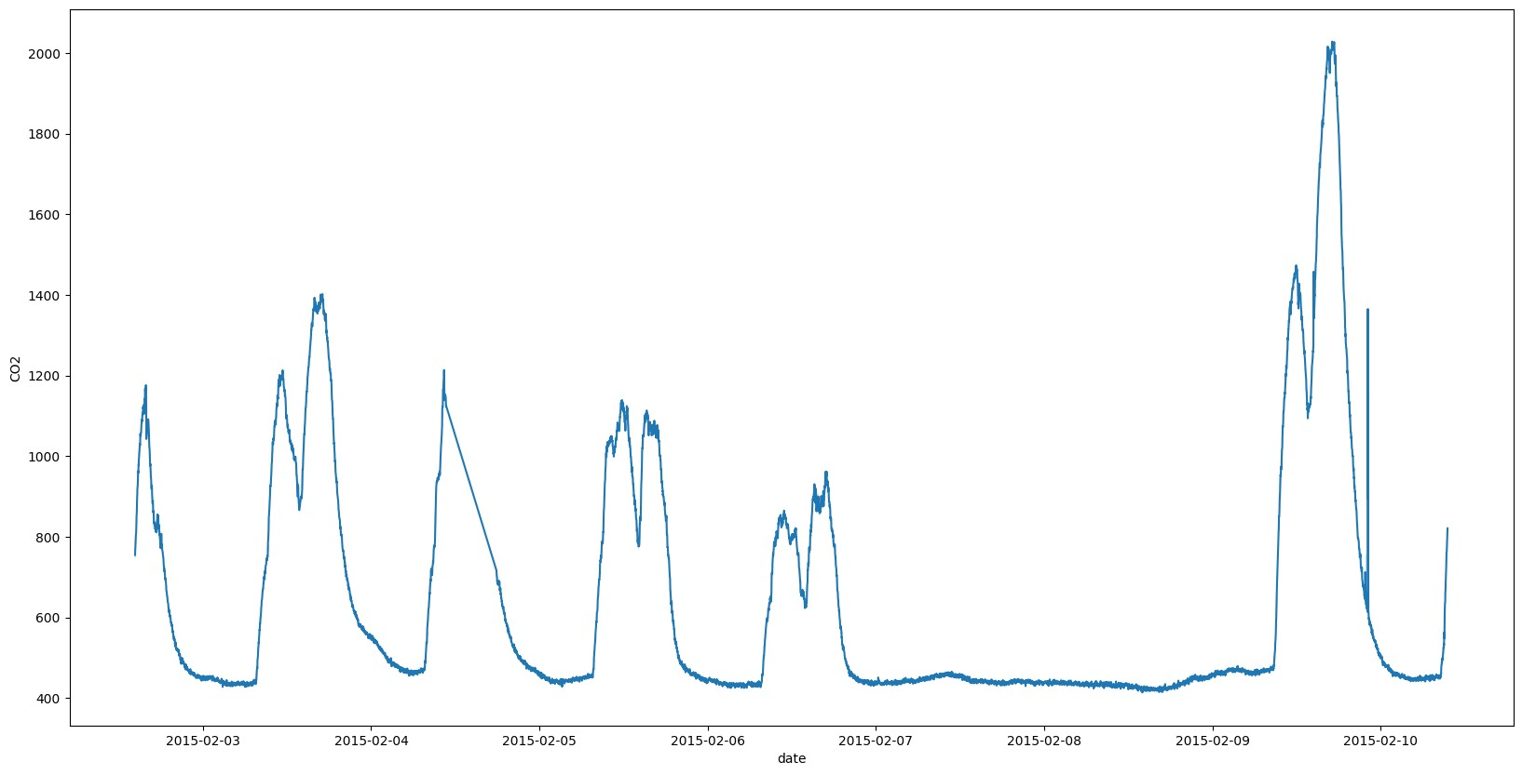

The co2 graph also shows the spikes in the co2 levels which indicates the presence of person in the room, assuming that there is no other source of co2 in the room.In addition to that the spikes also shows correspondence with the temperature graph and light graph. However from 7th of February to 9th of February, the co2 levels where minimum, which indicstes that the room was not occupied during that time. This observation contradicts with the humidity graph and temperature graph.

## Visualizing the humidity ratio fluctuations over time

|  |
| --- |
| *#lineplot for humidity ratio changes for time* plt**.**figure(figsize**=**(20,10)) sns**.**lineplot(x**=**'date',y**=**'HumidityRatio',data**=**df) plt**.**show() |

In [ ]:

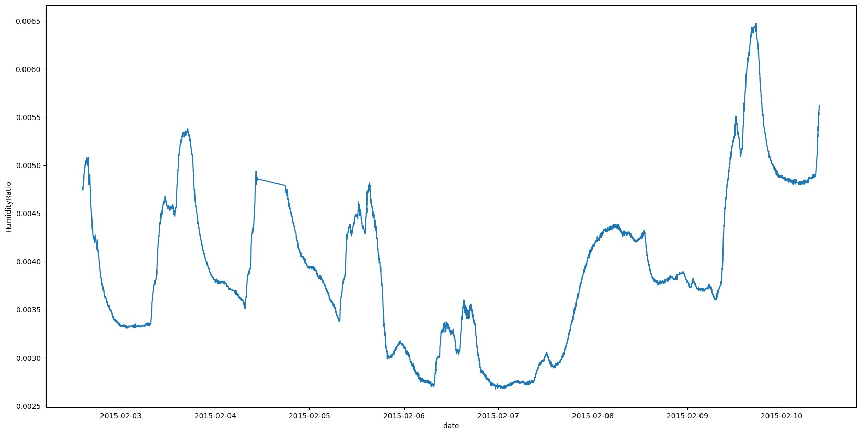

The humidity ratio graph is quite similar to the humidity graph. The spikes in the graph indicates the presence of people in the room. Moreover the same assumption is made about the humidity ratio after 9th of February.

# Correlation between the variables

**Correlation Heatmap**

|  |
| --- |
| *#correlation heatmap* plt**.**figure(figsize**=**(20,10)) sns**.**heatmap(df**.**corr(),annot**=True**) plt**.**show() |

In [ ]:

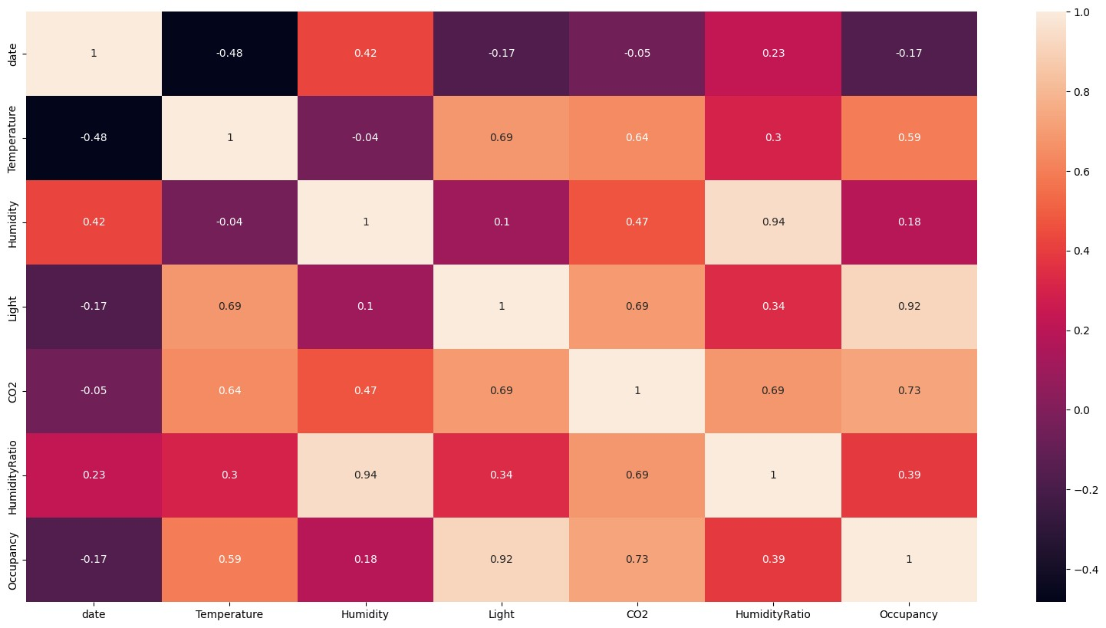

There is a strong coorelation between light and occupancy as well as between humidity and humidity ratio. The co2 levels and temperature also shows a strong correlation with the occupancy. However the humidity and humidity ratio has very less correlation with the occupancy.

## Temperature and Occupancy

|  |
| --- |
| *#violinplot for temperature*  sns**.**violinplot(y **=** df['Temperature'],x **=** df['Occupancy']) plt**.**xlabel('Occupancy') plt**.**ylabel('Temperature') plt**.**show() |

In [ ]:

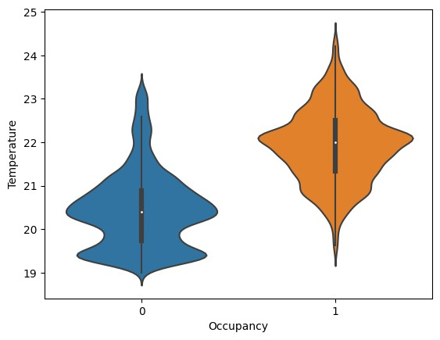

The temperature and occupancy graph shows that the temperature of the room increases when there is a person in the room. This is because of the heat emitted by the human body. The temperature of the room decreases when there is no person in the room. This proves the hypothesis regarding the peaks in the temperature graph.

## Light and Occupancy

|  |
| --- |
| *#boxplot for light*  sns**.**boxplot(y **=** df['Light'],x **=** df['Occupancy']) plt**.**xlabel('Occupancy') plt**.**ylabel('Light') plt**.**show() |

In [ ]:

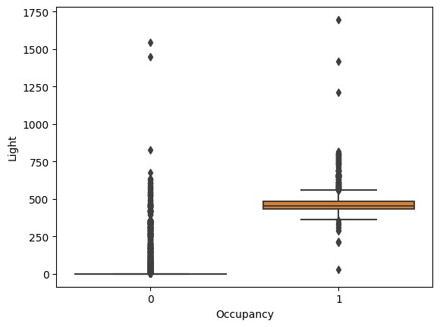

The light intensity of the room increases when there is a person in the room. This is because the lights are turned on when there is a person in the room. The light intensity of the room decreases when there is no person in the room. This proves the hypothesis regarding the peaks in the light graph. The outliers in the boxplot and the curves in the ligh graph might be due to sunlight entering the room.

## CO2 and Occupancy

|  |
| --- |
| *#violinlot for co2*  sns**.**violinplot(y **=** df['CO2'],x **=** df['Occupancy']) plt**.**xlabel('Occupancy') plt**.**ylabel('CO2') plt**.**show() |

In [ ]:

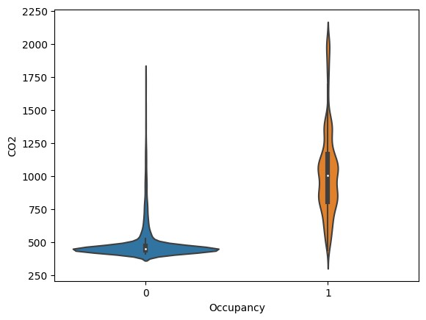

The CO2 levels of the room increases when there is a person in the room. This is because of the CO2 emitted by the human body. The CO2 levels of the room decreases when there is no person in the room. This proves the hypothesis regarding the peaks in the CO2 graph.

From the above EDA, it is quite clear that the temperature, light and CO2 levels of the room are a good indicator of the occupancy of the room. Therefore we will be using these three variables for our classification model.

# Data Preprocessing 2

|  |
| --- |
| *#dropping columns humidity, date and humidity ratio*  df**.**drop(['Humidity','date','HumidityRatio'],axis**=**1,inplace**=True**) |

In [ ]:

|  |
| --- |
| df**.**head(10) |

In [ ]:

Out[ ]: **Temperature Light CO2 Occupancy**

**0** 23.7000 585.200000 749.200000 1

|  |  |  |  |  |
| --- | --- | --- | --- | --- |
| **1** | 23.7180 | 578.400000 | 760.400000 | 1 |
| **2** | 23.7300 | 572.666667 | 769.666667 | 1 |
| **3** | 23.7225 | 493.750000 | 774.750000 | 1 |
| **4** | 23.7540 | 488.600000 | 779.000000 | 1 |
| **5** | 23.7600 | 568.666667 | 790.000000 | 1 |
| **6** | 23.7300 | 536.333333 | 798.000000 | 1 |
| **7** | 23.7540 | 509.000000 | 797.000000 | 1 |
| **8** | 23.7540 | 476.000000 | 803.200000 | 1 |
| **9** | 23.7360 | 510.000000 | 809.000000 | 1 |

# Train Test Split

In [ ]: **from** sklearn.model_selection **import** train_test_split x_train,x_test,y_train,y_test **=** train_test_split(df**.**drop(['Occupancy'],axis**=**1),d

# Model Building

**Random Tree Classifier**

In [ ]: **from** sklearn.ensemble **import** RandomForestClassifier rfc **=** RandomForestClassifier() rfc

Out[ ]: ▾RandomForestClassifier

RandomForestClassifier()

## Training the model

In [ ]: *#training the model* rfc**.**fit(x_train,y_train) *#training accuracy* rfc**.**score(x_train,y_train)

Out[ ]: 1.0

# Model Evaluation

In [ ]: rfc_pred **=** rfc**.**predict(x_test)

|  |
| --- |
| *#confusion matrix heatmap*  **from** sklearn.metrics **import** confusion_matrix sns**.**heatmap(confusion_matrix(y_test,rfc_pred),annot**=True**) plt**.**ylabel('Predicted') plt**.**xlabel('Actual') plt**.**show() |

In [ ]:

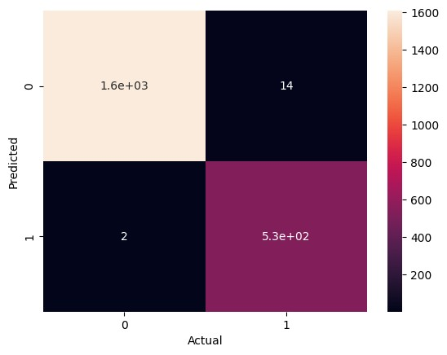

|  |
| --- |
| *#distribution plot for the predicted and actual values* ax **=** sns**.**distplot(y_test,hist**=False**,label**=**'Actual', color**=**'r') sns**.**distplot(rfc_pred,hist**=False**,label**=**'Predicted',color**=**'b',ax**=**ax) plt**.**show() |

In [ ]:

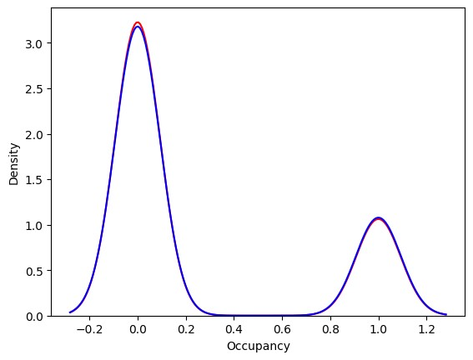

|  |
| --- |
| **from** sklearn.metrics **import** classification_report print(classification_report(y_test,rfc_pred)) |

In [ ]:

precision recall f1-score support

0 1.00 0.99 1.00 1623 1 0.97 1.00 0.99 534

accuracy 0.99 2157 macro avg 0.99 0.99 0.99 2157 weighted avg 0.99 0.99 0.99 2157

|  |
| --- |
| **from** sklearn.metrics **import** accuracy_score **from** sklearn.metrics **import** precision_score **from** sklearn.metrics **import** recall_score **from** sklearn.metrics **import** f1_score |

In [ ]:

|  |
| --- |
| print('Accuracy Score : ' **+** str(accuracy_score(y_test,rfc_pred))) print('Precision Score : ' **+** str(precision_score(y_test,rfc_pred))) print('Recall Score : ' **+** str(recall_score(y_test,rfc_pred))) print('F1 Score : ' **+** str(f1_score(y_test,rfc_pred))) |

In [ ]:

Accuracy Score : 0.9925822902178952

Precision Score : 0.9743589743589743

Recall Score : 0.9962546816479401

F1 Score : 0.9851851851851853

# Testing the model on new dataset

|  |
| --- |
| df_new **=** pd**.**read_csv('datatest2.csv') df_new**.**head() |

In [ ]:

Out[ ]: **date Temperature Humidity Light CO2 HumidityRatio Occupan**

2/11/2015

**0** 21.7600 31.133333 437.333333 1029.666667 0.005021

14:48

|  |  |  |  |  |  |  |  |
| --- | --- | --- | --- | --- | --- | --- | --- |
| **1** | 2/11/2015 14:49 | 21.7900 | 31.000000 | 437.333333 | 1000.000000 |  | 0.005009 |
| **2** | 2/11/2015 14:50 | 21.7675 | 31.122500 | 434.000000 | 1003.750000 |  | 0.005022 |
| **3** | 2/11/2015 14:51 | 21.7675 | 31.122500 | 439.000000 | 1009.500000 |  | 0.005022 |
| **4** | 2/11/2015 14:51 | 21.7900 | 31.133333 | 437.333333 | 1005.666667 |  | 0.005030 |

|  |
| --- |
| *#dropping columns humidity, date and humidity ratio*  df_new**.**drop(['Humidity','date','HumidityRatio'],axis**=**1,inplace**=True**) |

In [ ]:

|  |
| --- |
| *#splitting the target variable* x **=** df_new**.**drop(['Occupancy'],axis**=**1) y **=** df_new['Occupancy'] |

In [ ]:

|  |
| --- |
| *#predicting the values* pred **=** rfc**.**predict(x) |

In [ ]:

|  |
| --- |
| *#confusion matrix heatmap*  sns**.**heatmap(confusion_matrix(y,pred),annot**=True**) plt**.**ylabel('Predicted') plt**.**xlabel('Actual') plt**.**show() |

In [ ]:

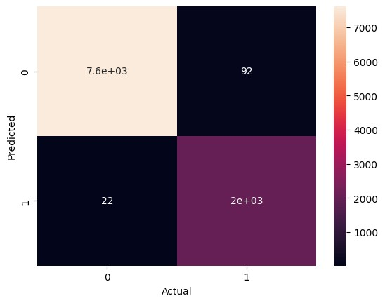

|  |
| --- |
| *#distribution plot for the predicted and actual values* ax **=** sns**.**distplot(y,hist**=False**,label**=**'Actual', color**=**'r') sns**.**distplot(pred,hist**=False**,label**=**'Predicted',color**=**'b',ax**=**ax) plt**.**show() |

In [ ]:

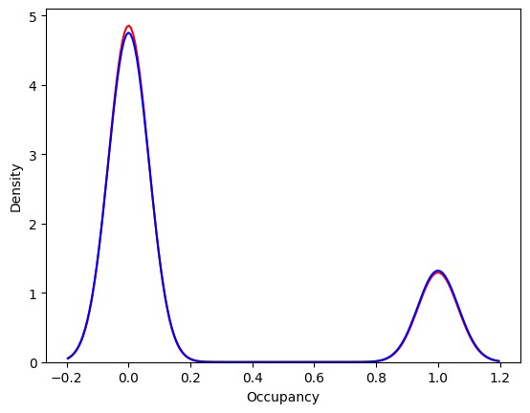

|  |
| --- |
| print(classification_report(y,pred)) |

In [ ]: precision recall f1-score support

0 1.00 0.99 0.99 7703 1 0.96 0.99 0.97 2049

accuracy 0.99 9752 macro avg 0.98 0.99 0.98 9752 weighted avg 0.99 0.99 0.99 9752

|  |
| --- |
| print('Accuracy Score : ' **+** str(accuracy_score(y,pred))) print('Precision Score : ' **+** str(precision_score(y,pred))) print('Recall Score : ' **+** str(recall_score(y,pred))) print('F1 Score : ' **+** str(f1_score(y,pred))) |

In [ ]:

Accuracy Score : 0.9883100902379

Precision Score : 0.9565832940066069

Recall Score : 0.9892630551488532

F1 Score : 0.9726487523992322

# Conclusion

From the above models we can see that the Random Forest Classifier has the highest accuracy score of 98%. Therefore we will be using the Random Forest Classifier for our final model. I also conclude that from the exploratory data analysis, it was found that the change in room temperature, CO levels and light intensity can be used to predict the occupancy of the room, inplace of humidity and humidity ratio.